**Ideation Phase**

**Brainstorm & Idea Prioritization Template**

|  |  |
| --- | --- |
| Date | 19 September 2022 |
| Team ID | PNT2022TMID50833 |
| Project Name | Plasma Donor Application |
| Maximum Marks | 4 Marks |

**Plasma Donor Application:**

This system is used if anyone needs a plasma donor. This system comprises of admin and user where both can request for a plasma .In this system there is something called an active user, which means the user is an active member of the app and only such people are mostly recommended here for Plasma donation.

**Step-1: Team Gathering, Collaboration and Select the Problem Statement**

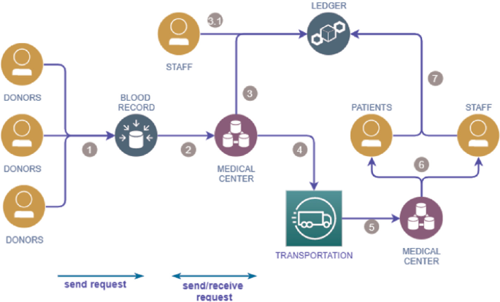

**Step-2: Brainstorm, Idea Listing and Grouping**

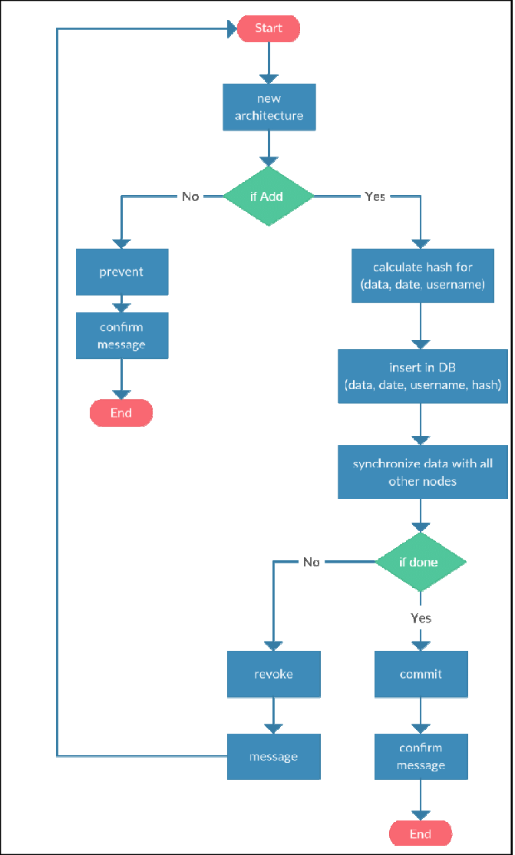

**Step-3: Idea Prioritization**

